E-HEALTHCARE

MANAGEMENT SYSTEM (PYTHON)

MINOR PROJECT REPORT

By

NITHIN VIKNESH (RA221030010181)
TADEPALLY DATTA MANI ANURAG (RA2211030010178)

Under the guidance of
Dr. S. Thenmalar
In partial fulfilment for the Course
of

21CSC203P – ADVANCED PROGRAMMING PRACTICE

in NETWORKING AND COMMUNICTION



FACULTY OF ENGINEERING AND TECHNOLOGY
SCHOOL OF COMPUTING
SRM INSTITUTE OF SCIENCE AND TECHNOLOGY
KATTANKULATHUR

NOVEMBER 2023

SRM INSTITUTE OF SCIENCE AND TECHNOLOGY

(Under Section 3 of UGC Act, 1956)

BONAFIDE CERTIFICATE

Certified that this minor project report for the course 21CSC203P - ADVANCED PROGRAMMING PRACTICE entitled in "E-HEALTHCARE MANAGEMENT SYSTEM" is the bonafide work of NITHIN VIKNESH (RA221030010181) and TADEPALLY DATTA MANI ANURAG (RA2211030010178) who carried out the work under my supervision.

FACULTY IN-CHARGE
Dr. S. Thenmalar
Associate Professor
Department of Networking and
Communications
SRM Institute of Science and Technology
Kattankulathur

ABSTRACT

The Hospital Management System is a user-friendly tool that helps healthcare places run better. It connects well with a strong database, managing patient info, appointments, and payments smoothly. The design is easy, making it simple for doctors and staff to handle patient records. It's versatile and handles different details, making patient record management complete.
Apart from patient records, it's great at scheduling appointments. The billing feature is strong, ensuring clear financial transactions and helping with efficient financial management and reporting.
The 'View Patients' tool is user-friendly, giving quick access to all patient records. The design is easy to understand, reducing the learning curve for users, even for staff not familiar with technology.
This project shows how combining a user-friendly design and a strong database can improve hospital record management. Overall, the Hospital Management System is an efficient solution for healthcare places, making patient care better, administrative processes smoother, and healthcare operations more efficient. It proves how using technology positively changes healthcare management.

ACKNOWLEDGEMENT

We express our heartfelt thanks to our honorable Vice Chancellor Dr. C. MUTHAMIZHCHELVAN, for being the beacon in all our endeavors.
We would like to express my warmth of gratitude to our Registrar Dr. S. Ponnusamy, for his encouragement.
We express our profound gratitude to our Dean (College of Engineering and Technology) Dr. T. V. Gopal, for bringing out novelty in all executions.
We would like to express my heartfelt thanks to Chairperson, School of Computing Dr. Revathi Venkataraman, for imparting confidence to complete my course project
We wish to express my sincere thanks to Course Audit Professors Dr. Vadivu. G, Professor, Department of Data Science and Business Systems and Dr. Sasikala. E Professor, Department of Data Science and Business Systems and Course Coordinators for their constant encouragement and support.
We are highly thankful to our Course project Faculty Dr. S. Thenmalar, Associate Professor, Department of Networking and Communications, for her assistance, timely suggestion and guidance throughout the duration of this course project.
We extend my gratitude to our HoD Dr. Annapurani. K Professor and Head, Department of Networking and Communications and my Departmental colleagues for their Support.
Finally, we thank our parents and friends near and dear ones who directly and indirectly contributed to the successful completion of our project. Above all, I thank the almighty for showering his blessings on me to complete my Course project.

TABLE OF CONTENTS

CHAPTER NO |  | CONTENTS | PAGE NO
1 | INTRODUCTION
 | 1.1 Motivation
 | 1.2 Objective
 | 1.3 Problem Statement
 | 1.4 Challenges
2 | LITERATURE SURVEY
3 | REQUIREMENT ANALYSIS
4 | ARCHITECTURE & DESIGN
5 | IMPLEMENTATION
6 | EXPERIMENT RESULTS & ANALYSIS
7 | CONCLUSION
8 | REFERENCES

- INTRODUCTION

  - Motivation:

The motivation behind developing a Hospital Management System (HMS) using Python lies in the need for an efficient and streamlined approach to healthcare administration. A well-designed HMS can significantly enhance the overall quality of patient care, optimize resource utilization, and improve the decision-making process within a hospital. By leveraging Python's versatility, we aim to create a robust system that automates various tasks, reduces manual errors, and ultimately contributes to the enhancement of healthcare services.

  - Objective:

The primary objective of this project is to develop a Hospital Management System using Python that addresses the complexities of healthcare administration. The system aims to streamline processes such as patient registration, appointment scheduling, billing, and inventory management, fostering a more organized and efficient healthcare environment. By leveraging Python's capabilities, we seek to create a user-friendly and scalable solution that caters to the diverse needs of hospital staff, administrators, and patients.

  - Problem Statement:

The current state of hospital management often involves manual and paper-based processes, leading to inefficiencies, errors, and delays. Inaccurate record-keeping, difficulties in appointment scheduling, and challenges in managing resources can hinder the smooth operation of healthcare facilities. This project aims to tackle these issues by developing a comprehensive Hospital Management System using Python, providing a centralized platform for data management, communication, and decision support.

1.4 Challenges:

- Integration of Existing Systems: Integrating the new HMS with existing hospital systems (such as Electronic Health Records) poses a challenge, requiring careful planning and execution to ensure seamless data flow and interoperability.
- User Adoption: Ensuring that the hospital staff is comfortable with the new system is crucial. User training and change management strategies must be implemented to facilitate a smooth transition and promote user acceptance.
- Data Security and Privacy: Healthcare systems deal with sensitive patient information, making data security and privacy paramount. Implementing robust security measures to protect patient data and comply with relevant regulations is a critical challenge.
- Scalability: As the hospital grows, the system should be able to scale accordingly. Designing the HMS to accommodate an increasing number of patients, staff, and services while maintaining performance is a key challenge.

- Real-time Updates: Providing real-time updates on patient statuses, bed availability, and resource utilization requires efficient data processing and communication mechanisms. Achieving low-latency and reliable updates is a technical challenge to be addressed.
- Customization and Flexibility: Hospitals have diverse workflows and requirements. Designing the system to be customizable and flexible enough to adapt to different hospital settings and workflows is a challenge that needs careful consideration.

By addressing these challenges, the Hospital Management System developed in Python aims to contribute to the overall efficiency, accuracy, and quality of healthcare services provided by the hospital.

- REQUIREMENTS

2.1 Software Requirements

- Operating System Compatibility The application should be compatible with popular operating systems, including Windows, macOS, and Linux.
- Python interpreter, Tkinter
- GUI Framework Utilize Tkinter to create an intuitive and responsive graphical user interface (GUI) for E healthcare management system
- Database Management for database connectivity to support various relational databases (e.g., MySQL, PostgreSQL, SQLite).
- User Authentication Optional but recommended: Provide user authentication mechanisms to safeguard data access.
- Data Storage Define data structures and schema for efficient storage and retrieval of expense records.

2.2 Hardware Requirements

- Processor (1 GHz+)
- Memory (RAM, 2 GB+)
- Storage Space (Variable)
- Screen Resolution (1280x720+)
- Input Devices (Keyboard, Mouse)
- Network Connection (For remote database)

- ARCHITECTURE AND DESIGN

  - Flow Chart

Login Page
Patient Tab
Doctor Tab
Appointments Tab
Pharmacy Tab
Report Tab

- IMPLEMENTATION

5.1 Source Code
import tkinter as tk
from tkinter import ttk
import mysql.connector
from datetime import datetime

# Connect to MySQL
db = mysql.connector.connect(
host="localhost",
user="root",
password="*********",
database="Hospital"
)
cursor = db.cursor()

cursor.execute("""
CREATE TABLE IF NOT EXISTS patients (
id INT AUTO_INCREMENT PRIMARY KEY,
name VARCHAR(255),
age INT,
gender VARCHAR(10),
phone_number VARCHAR(15),
bill_due DECIMAL(10, 2)
)
""")
cursor.execute("""
CREATE TABLE IF NOT EXISTS doctors (
id INT AUTO_INCREMENT PRIMARY KEY,
name VARCHAR(255),
specialization VARCHAR(255),
salary DECIMAL(10, 2)
)
""")
cursor.execute("""
CREATE TABLE IF NOT EXISTS appointments (
id INT AUTO_INCREMENT PRIMARY KEY,
patient_id INT,
doctor_id INT,
time VARCHAR(20),
date DATE,
FOREIGN KEY (patient_id) REFERENCES patients(id),
FOREIGN KEY (doctor_id) REFERENCES doctors(id)
)
""")
cursor.execute("""
CREATE TABLE IF NOT EXISTS pharmacy (
id INT AUTO_INCREMENT PRIMARY KEY,
medicine_name VARCHAR(255),
quantity INT,
price DECIMAL(10, 2),
expiry_date DATE
)
""")
cursor.execute("""
CREATE TABLE IF NOT EXISTS reports (
id INT AUTO_INCREMENT PRIMARY KEY,
patient_id INT,
doctor_id INT,
diagnosis TEXT,
medicine_prescribed TEXT,
bill_amount DECIMAL(10, 2),
FOREIGN KEY (patient_id) REFERENCES patients(id),
FOREIGN KEY (doctor_id) REFERENCES doctors(id)
)
""")
cursor.execute("""
CREATE TABLE IF NOT EXISTS users (
id INT AUTO_INCREMENT PRIMARY KEY,
username VARCHAR(255),
password VARCHAR(255)
)
""")
db.commit()

# GUI
class HospitalManagementSystem:
def __init__(self, root):
self.root = root
self.root.title("E-Healthcare Management System")

# Hospital Name
self.hospital_name_label = tk.Label(self.root, text="SRM Hospitals", font=('Helvetica', 26, 'bold'))
self.hospital_name_label.pack(pady=10)

# Live Date and Time
self.date_time_label = tk.Label(self.root, font=('Helvetica', 12))
self.date_time_label.pack(pady=5)

# Tabs
self.notebook = ttk.Notebook(root)
self.login_tab = ttk.Frame(self.notebook)
self.patient_tab = ttk.Frame(self.notebook)
self.doctor_tab = ttk.Frame(self.notebook)
self.appointment_tab = ttk.Frame(self.notebook)
self.pharmacy_tab = ttk.Frame(self.notebook)
self.report_tab = ttk.Frame(self.notebook)

self.notebook.add(self.login_tab, text='Login')
self.notebook.add(self.patient_tab, text='Patients', state='disabled')
self.notebook.add(self.doctor_tab, text='Doctors', state='disabled')
self.notebook.add(self.appointment_tab, text='Appointments', state='disabled')
self.notebook.add(self.pharmacy_tab, text='Pharmacy', state='disabled')
self.notebook.add(self.report_tab, text='Report', state='disabled')
# Login Tab
self.create_login_tab()

# Patient Tab
self.create_patient_tab()

# Doctor Tab
self.create_doctor_tab()

# Appointment Tab
self.create_appointment_tab()

# Pharmacy Tab
self.create_pharmacy_tab()

#Report tab
self.create_report_tab()

self.notebook.pack()

# Update date and time every second
self.update_date_time()

def update_date_time(self):
current_time = datetime.now().strftime("%Y-%m-%d %H:%M:%S")
self.date_time_label.config(text=f"Current Date and Time: {current_time}")
self.root.after(1000, self.update_date_time)

def create_login_tab(self):
# User ID Entry
self.user_id_label = tk.Label(self.login_tab, text="User ID:")
self.user_id_entry = tk.Entry(self.login_tab)

# Password Entry
self.password_label = tk.Label(self.login_tab, text="Password:")
self.password_entry = tk.Entry(self.login_tab, show="*")

# Login Button
self.login_button = tk.Button(self.login_tab, text="Login", command=self.login)

# Grid
self.user_id_label.grid(row=0, column=0, pady=10)
self.user_id_entry.grid(row=0, column=1, pady=10)

self.password_label.grid(row=1, column=0, pady=10)
self.password_entry.grid(row=1, column=1, pady=10)

self.login_button.grid(row=2, column=0, columnspan=2, pady=10)

def login(self):
username = self.user_id_entry.get()
password = self.password_entry.get()

# Check the credentials in the 'users' table
cursor.execute("SELECT * FROM users WHERE username = %s AND password = %s", (username, password))
result = cursor.fetchone()

if result:
# If the login is successful, enable all tabs and switch to the Patients tab
for tab in (self.patient_tab, self.doctor_tab, self.appointment_tab, self.pharmacy_tab, self.report_tab):
self.notebook.tab(tab, state='normal')
self.notebook.select(self.patient_tab)
else:
# Display an error message for unsuccessful login
tk.messagebox.showerror("Login Failed", "Invalid username or password")

def create_patient_tab(self):
# Patient Entry
self.patient_name_label = tk.Label(self.patient_tab, text="Name:")
self.patient_name_entry = tk.Entry(self.patient_tab)

self.patient_age_label = tk.Label(self.patient_tab, text="Age:")
self.patient_age_entry = tk.Entry(self.patient_tab)

self.patient_gender_label = tk.Label(self.patient_tab, text="Gender:")
self.patient_gender_var = tk.StringVar(self.patient_tab)
self.patient_gender_combobox = ttk.Combobox(self.patient_tab, textvariable=self.patient_gender_var,
values=["Male", "Female", "Other"])

self.phone_number_label = tk.Label(self.patient_tab, text="Phone Number:")
self.phone_number_entry = tk.Entry(self.patient_tab)

self.bill_due_label = tk.Label(self.patient_tab, text="Bill Due:")
self.bill_due_entry = tk.Entry(self.patient_tab)

self.add_patient_button = tk.Button(self.patient_tab, text="Add Patient", command=self.add_patient)
self.edit_patient_button = tk.Button(self.patient_tab, text="Edit Patient", command=self.edit_patient)
self.update_patient_button = tk.Button(self.patient_tab, text="Update Patient", command=self.update_patient)
self.delete_patient_button = tk.Button(self.patient_tab, text="Delete Patient", command=self.delete_patient)

# Patient Treeview
self.patients_tree = ttk.Treeview(self.patient_tab, columns=('ID', 'Name', 'Age', 'Gender', 'Phone Number', 'Bill Due'))
self.patients_tree.heading('ID', text='ID')
self.patients_tree.heading('Name', text='Name')
self.patients_tree.heading('Age', text='Age')
self.patients_tree.heading('Gender', text='Gender')
self.patients_tree.heading('Phone Number', text='Phone Number')
self.patients_tree.heading('Bill Due', text='Bill Due')

# Grid
self.patient_name_label.grid(row=0, column=0)
self.patient_name_entry.grid(row=0, column=1)

self.patient_age_label.grid(row=1, column=0)
self.patient_age_entry.grid(row=1, column=1)

self.patient_gender_label.grid(row=2, column=0)
self.patient_gender_combobox.grid(row=2, column=1)

self.phone_number_label.grid(row=3, column=0)
self.phone_number_entry.grid(row=3, column=1)

self.bill_due_label.grid(row=4, column=0)
self.bill_due_entry.grid(row=4, column=1)

self.add_patient_button.grid(row=5, column=0, columnspan=2)
self.edit_patient_button.grid(row=5, column=2, columnspan=2)
self.update_patient_button.grid(row=5, column=4, columnspan=2)
self.delete_patient_button.grid(row=5, column=6, columnspan=2)

self.patients_tree.grid(row=6, column=0, columnspan=8)

# Load Patients on startup
self.load_patients()

def add_patient(self):
name = self.patient_name_entry.get()
age = self.patient_age_entry.get()
gender = self.patient_gender_var.get()
phone_number = self.phone_number_entry.get()
bill_due = self.bill_due_entry.get()

# Inserting data into the 'patients' table
cursor.execute("INSERT INTO patients (name, age, gender, phone_number, bill_due) VALUES (%s, %s, %s, %s, %s)",
(name, age, gender, phone_number, bill_due))
db.commit()

# Update the patient list
self.load_patients()

def edit_patient(self):
selected_item = self.patients_tree.selection()
if selected_item:
patient_id, name, age, gender, phone_number, bill_due = self.patients_tree.item(selected_item, 'values')
self.patient_name_entry.delete(0, tk.END)
self.patient_age_entry.delete(0, tk.END)
self.patient_name_entry.insert(0, name)
self.patient_age_entry.insert(0, age)
self.patient_gender_var.set(gender)
self.phone_number_entry.delete(0, tk.END)
self.phone_number_entry.insert(0, phone_number)
self.bill_due_entry.delete(0, tk.END)
self.bill_due_entry.insert(0, bill_due)

def update_patient(self):
selected_item = self.patients_tree.selection()
if selected_item:
patient_id = self.patients_tree.item(selected_item, 'values')[0]
name = self.patient_name_entry.get()
age = self.patient_age_entry.get()
gender = self.patient_gender_var.get()
phone_number = self.phone_number_entry.get()
bill_due = self.bill_due_entry.get()

# Updating data in the 'patients' table
cursor.execute("UPDATE patients SET name=%s, age=%s, gender=%s, phone_number=%s, bill_due=%s WHERE id=%s",
(name, age, gender, phone_number, bill_due, patient_id))
db.commit()

# Update the patient list
self.load_patients()

def delete_patient(self):
selected_item = self.patients_tree.selection()
if selected_item:
patient_id = self.patients_tree.item(selected_item, 'values')[0]

# Deleting data from the 'patients' table
cursor.execute("DELETE FROM patients WHERE id=%s", (patient_id,))
db.commit()

# Update the patient list
self.load_patients()

def load_patients(self):
# Clearing the existing data in the treeview
for item in self.patients_tree.get_children():
self.patients_tree.delete(item)

# Fetching patients from the database
cursor.execute("SELECT * FROM patients")
patients = cursor.fetchall()

# Inserting the updated data
for patient in patients:
self.patients_tree.insert('', 'end', values=patient)

def create_doctor_tab(self):
# Doctor Entry
self.doctor_name_label = tk.Label(self.doctor_tab, text="Name:")
self.doctor_name_entry = tk.Entry(self.doctor_tab)

self.specialization_label = tk.Label(self.doctor_tab, text="Specialization:")
self.specialization_entry = tk.Entry(self.doctor_tab)

self.salary_label = tk.Label(self.doctor_tab, text="Salary:")
self.salary_entry = tk.Entry(self.doctor_tab)

self.add_doctor_button = tk.Button(self.doctor_tab, text="Add Doctor", command=self.add_doctor)
self.edit_doctor_button = tk.Button(self.doctor_tab, text="Edit Doctor", command=self.edit_doctor)
self.update_doctor_button = tk.Button(self.doctor_tab, text="Update Doctor", command=self.update_doctor)
self.delete_doctor_button = tk.Button(self.doctor_tab, text="Delete Doctor", command=self.delete_doctor)

# Doctor Treeview
self.doctors_tree = ttk.Treeview(self.doctor_tab, columns=('ID', 'Name', 'Specialization', 'Salary'))
self.doctors_tree.heading('ID', text='ID')
self.doctors_tree.heading('Name', text='Name')
self.doctors_tree.heading('Specialization', text='Specialization')
self.doctors_tree.heading('Salary', text='Salary')

# Grid
self.doctor_name_label.grid(row=0, column=0)
self.doctor_name_entry.grid(row=0, column=1)

self.specialization_label.grid(row=1, column=0)
self.specialization_entry.grid(row=1, column=1)

self.salary_label.grid(row=2, column=0)
self.salary_entry.grid(row=2, column=1)

self.add_doctor_button.grid(row=5, column=0, columnspan=2)
self.edit_doctor_button.grid(row=5, column=2, columnspan=2)
self.update_doctor_button.grid(row=5, column=4, columnspan=2)
self.delete_doctor_button.grid(row=5, column=6, columnspan=2)

self.doctors_tree.grid(row=6, column=0, columnspan=8)

# Load Doctors on startup
self.load_doctors()

def add_doctor(self):
name = self.doctor_name_entry.get()
specialization = self.specialization_entry.get()
salary = self.salary_entry.get()

# Inserting data into the 'doctors' table
cursor.execute("INSERT INTO doctors (name, specialization, salary) VALUES (%s, %s, %s)", (name, specialization, salary))
db.commit()

# Update the doctor list
self.load_doctors()

def edit_doctor(self):
selected_item = self.doctors_tree.selection()
if selected_item:
doctor_id, name, specialization, salary = self.doctors_tree.item(selected_item, 'values')
self.doctor_name_entry.delete(0, tk.END)
self.specialization_entry.delete(0, tk.END)
self.salary_entry.delete(0, tk.END)
self.doctor_name_entry.insert(0, name)
self.specialization_entry.insert(0, specialization)
self.salary_entry.insert(0, salary)

def update_doctor(self):
selected_item = self.doctors_tree.selection()
if selected_item:
doctor_id = self.doctors_tree.item(selected_item, 'values')[0]
name = self.doctor_name_entry.get()
specialization = self.specialization_entry.get()
salary = self.salary_entry.get()

# Updating data in the 'doctors' table
cursor.execute("UPDATE doctors SET name=%s, specialization=%s, salary=%s WHERE id=%s", (name, specialization, salary, doctor_id))
db.commit()

# Update the doctor list
self.load_doctors()

def delete_doctor(self):
selected_item = self.doctors_tree.selection()
if selected_item:
doctor_id = self.doctors_tree.item(selected_item, 'values')[0]

# Deleting data from the 'doctors' table
cursor.execute("DELETE FROM doctors WHERE id=%s", (doctor_id,))
db.commit()

# Update the doctor list
self.load_doctors()

def load_doctors(self):
# Clearing the existing data in the treeview
for item in self.doctors_tree.get_children():
self.doctors_tree.delete(item)

# Fetching doctors from the database
cursor.execute("SELECT * FROM doctors")
doctors = cursor.fetchall()

# Inserting the updated data
for doctor in doctors:
self.doctors_tree.insert('', 'end', values=doctor)

def create_appointment_tab(self):
# Appointment Entry
self.appointment_patient_label = tk.Label(self.appointment_tab, text="Patient:")
self.appointment_patient_var = tk.StringVar(self.appointment_tab)
self.appointment_patient_combobox = ttk.Combobox(self.appointment_tab, textvariable=self.appointment_patient_var,
values=self.get_patient_names())

self.appointment_doctor_label = tk.Label(self.appointment_tab, text="Doctor:")
self.appointment_doctor_var = tk.StringVar(self.appointment_tab)
self.appointment_doctor_combobox = ttk.Combobox(self.appointment_tab, textvariable=self.appointment_doctor_var,
values=self.get_doctor_names())

self.appointment_time_label = tk.Label(self.appointment_tab, text="Time:")
self.appointment_time_entry = tk.Entry(self.appointment_tab)

self.appointment_date_label = tk.Label(self.appointment_tab, text="Date:")
self.appointment_date_entry = tk.Entry(self.appointment_tab)

self.add_appointment_button = tk.Button(self.appointment_tab, text="Add Appointment", command=self.add_appointment)
self.edit_appointment_button = tk.Button(self.appointment_tab, text="Edit Appointment", command=self.edit_appointment)
self.update_appointment_button = tk.Button(self.appointment_tab, text="Update Appointment", command=self.update_appointment)
self.delete_appointment_button = tk.Button(self.appointment_tab, text="Delete Appointment", command=self.delete_appointment)

# Appointment Treeview
self.appointments_tree = ttk.Treeview(self.appointment_tab, columns=('ID', 'Patient', 'Doctor', 'Time', 'Date'))
self.appointments_tree.heading('ID', text='ID')
self.appointments_tree.heading('Patient', text='Patient')
self.appointments_tree.heading('Doctor', text='Doctor')
self.appointments_tree.heading('Time', text='Time')
self.appointments_tree.heading('Date', text='Date')

# Grid
self.appointment_patient_label.grid(row=0, column=0)
self.appointment_patient_combobox.grid(row=0, column=1)

self.appointment_doctor_label.grid(row=1, column=0)
self.appointment_doctor_combobox.grid(row=1, column=1)

self.appointment_time_label.grid(row=2, column=0)
self.appointment_time_entry.grid(row=2, column=1)

self.appointment_date_label.grid(row=3, column=0)
self.appointment_date_entry.grid(row=3, column=1)

self.add_appointment_button.grid(row=4, column=0, columnspan=2)
self.edit_appointment_button.grid(row=4, column=2, columnspan=2)
self.update_appointment_button.grid(row=4, column=4, columnspan=2)
self.delete_appointment_button.grid(row=4, column=6, columnspan=2)

self.appointments_tree.grid(row=12, column=0, columnspan=8)

# Load Appointments on startup
self.load_appointments()

def add_appointment(self):
patient_name = self.appointment_patient_var.get()
doctor_name = self.appointment_doctor_var.get()
time = self.appointment_time_entry.get()
date = self.appointment_date_entry.get()

# Get patient and doctor IDs
patient_id = self.get_patient_id_by_name(patient_name)
doctor_id = self.get_doctor_id_by_name(doctor_name)

if patient_id and doctor_id:
# Inserting data into the 'appointments' table
cursor.execute("INSERT INTO appointments (patient_id, doctor_id, time, date) VALUES (%s, %s, %s, %s)",
(patient_id, doctor_id, time, date))
db.commit()

# Update the appointment list
self.load_appointments()

def edit_appointment(self):
selected_item = self.appointments_tree.selection()
if selected_item:
appointment_id, patient_name, doctor_name, time = self.appointments_tree.item(selected_item, 'values')
self.appointment_patient_var.set(patient_name)
self.appointment_doctor_var.set(doctor_name)
self.appointment_time_entry.delete(0, tk.END)
self.appointment_time_entry.insert(0, time)

def update_appointment(self):
selected_item = self.appointments_tree.selection()
if selected_item:
appointment_id = self.appointments_tree.item(selected_item, 'values')[0]
patient_name = self.appointment_patient_var.get()
doctor_name = self.appointment_doctor_var.get()
time = self.appointment_time_entry.get()

# Get patient and doctor IDs
patient_id = self.get_patient_id_by_name(patient_name)
doctor_id = self.get_doctor_id_by_name(doctor_name)

if patient_id and doctor_id:
# Updating data in the 'appointments' table
cursor.execute("UPDATE appointments SET patient_id=%s, doctor_id=%s, time=%s WHERE id=%s",
(patient_id, doctor_id, time, appointment_id))
db.commit()

# Update the appointment list
self.load_appointments()

def delete_appointment(self):
selected_item = self.appointments_tree.selection()
if selected_item:
appointment_id = self.appointments_tree.item(selected_item, 'values')[0]

# Deleting data from the 'appointments' table
cursor.execute("DELETE FROM appointments WHERE id=%s", (appointment_id,))
db.commit()

# Update the appointment list
self.load_appointments()

def load_appointments(self):
# Clearing the existing data in the treeview
for item in self.appointments_tree.get_children():
self.appointments_tree.delete(item)

# Fetching appointments from the database
cursor.execute("SELECT * FROM appointments")
appointments = cursor.fetchall()

# Inserting the updated data into the treeview
for appointment in appointments:
# Format the date before inserting into the Treeview
formatted_date = datetime.strftime(appointment[4], "%Y-%m-%d")
self.appointments_tree.insert('', 'end', values=(appointment[0], self.get_patient_name_by_id(appointment[1]),
self.get_doctor_name_by_id(appointment[2]), appointment[3],
formatted_date))

def create_pharmacy_tab(self):
# Medicine Entry
self.medicine_id_label = tk.Label(self.pharmacy_tab, text="Medicine ID:")
self.medicine_id_entry = tk.Entry(self.pharmacy_tab, state='disabled')

self.medicine_name_label = tk.Label(self.pharmacy_tab, text="Medicine Name:")
self.medicine_name_entry = tk.Entry(self.pharmacy_tab)

self.medicine_quantity_label = tk.Label(self.pharmacy_tab, text="Quantity:")
self.medicine_quantity_entry = tk.Entry(self.pharmacy_tab)

self.medicine_cost_label = tk.Label(self.pharmacy_tab, text="Medicine Cost:")
self.medicine_cost_entry = tk.Entry(self.pharmacy_tab)

self.medicine_expiry_label = tk.Label(self.pharmacy_tab, text="Expiry Date (YYYY-MM-DD):")
self.medicine_expiry_entry = tk.Entry(self.pharmacy_tab)

self.add_medicine_button = tk.Button(self.pharmacy_tab, text="Add Medicine", c o command=self.add_medicine)
selfco.edit_medicine_button = tk.Button(self.pharmacy_tab, text="Edit Medicine", c o mmand=self.edit_medicine)
self.update_medicine_button = tk.Button(self.pharmacy_tab, text="Update Medicine", command=self.update_medicine)
self.delete_medicine_button = tk.Button(self.pharmacy_tab, text="Delete Medicine", command=self.delete_medicine)

# Medicine Treeview
self.medicines_tree = ttk.Treeview(self.pharmacy_tab, columns=('ID', 'Medicine Name', 'Quantity', 'Cost', 'Expiry Date'))
self.medicines_tree.heading('ID', text='ID')
self.medicines_tree.heading('Medicine Name', text='Medicine Name')
self.medicines_tree.heading('Quantity', text='Quantity')
self.medicines_tree.heading('Cost', text='Cost')
self.medicines_tree.heading('Expiry Date', text='Expiry Date')

# Grid
self.medicine_id_label.grid(row=0, column=0)
self.medicine_id_entry.grid(row=0, column=1)

self.medicine_name_label.grid(row=1, column=0)
self.medicine_name_entry.grid(row=1, column=1)

self.medicine_quantity_label.grid(row=2, column=0)
self.medicine_quantity_entry.grid(row=2, column=1)

self.medicine_cost_label.grid(row=3, column=0)
self.medicine_cost_entry.grid(row=3, column=1)

self.medicine_expiry_label.grid(row=4, column=0)
self.medicine_expiry_entry.grid(row=4, column=1)

self.add_medicine_button.grid(row=5, column=0, columnspan=2)
self.edit_medicine_button.grid(row=5, column=2, columnspan=2)
self.update_medicine_button.grid(row=5, column=4, columnspan=2)
self.delete_medicine_button.grid(row=5, column=6, columnspan=2)

self.medicines_tree.grid(row=10, column=0, columnspan=8)

# Load Medicines on startup
self.load_medicines()

def add_medicine(self):
name = self.medicine_name_entry.get()
quantity = self.medicine_quantity_entry.get()
cost = self.medicine_cost_entry.get()
expiry_date = self.medicine_expiry_entry.get()

# Inserting data into the 'pharmacy' table
cursor.execute("INSERT INTO pharmacy (medicine_name, quantity, price, expiry_date) VALUES (%s, %s, %s, %s)",
(name, quantity, cost, expiry_date))
db.commit()

# Update the medicine list
self.load_medicines()

def edit_medicine(self):
selected_item = self.medicines_tree.selection()
if selected_item:
medicine_id, name, quantity, cost, expiry_date = self.medicines_tree.item(selected_item, 'values')
self.medicine_name_entry.delete(0, tk.END)
self.medicine_quantity_entry.delete(0, tk.END)
self.medicine_cost_entry.delete(0, tk.END)
self.medicine_expiry_entry.delete(0, tk.END)
self.medicine_name_entry.insert(0, name)
self.medicine_quantity_entry.insert(0, quantity)
self.medicine_cost_entry.insert(0, cost)
self.medicine_expiry_entry.insert(0, expiry_date)

def update_medicine(self):
selected_item = self.medicines_tree.selection()
if selected_item:
medicine_id = self.medicines_tree.item(selected_item, 'values')[0]
name = self.medicine_name_entry.get()
quantity = self.medicine_quantity_entry.get()
cost = self.medicine_cost_entry.get()
expiry_date = self.medicine_expiry_entry.get()

# Updating data in the 'pharmacy' table
cursor.execute("UPDATE pharmacy SET medicine_name=%s, quantity=%s, price=%s, expiry_date=%s WHERE id=%s",
(name, quantity, cost, expiry_date, medicine_id))
db.commit()

# Update the medicine list
self.load_medicines()

def delete_medicine(self):
selected_item = self.medicines_tree.selection()
if selected_item:
medicine_id = self.medicines_tree.item(selected_item, 'values')[0]

# Deleting data from the 'pharmacy' table
cursor.execute("DELETE FROM pharmacy WHERE id=%s", (medicine_id,))
db.commit()

# Update the medicine list
self.load_medicines()

def load_medicines(self):
# Clearing the existing data in the treeview
for item in self.medicines_tree.get_children():
self.medicines_tree.delete(item)

# Fetching data from the 'pharmacy' table
cursor.execute("SELECT * FROM pharmacy")
medicines = cursor.fetchall()

# Populating the treeview with the data
for medicine in medicines:
self.medicines_tree.insert("", "end", values=medicine)

def get_patient_names(self):
cursor.execute("SELECT name FROM patients")
return [row[0] for row in cursor.fetchall()]

def get_doctor_names(self):
cursor.execute("SELECT name FROM doctors")
return [row[0] for row in cursor.fetchall()]

def get_patient_id_by_name(self, name):
cursor.execute("SELECT id FROM patients WHERE name = %s", (name,))
result = cursor.fetchone()
return result[0] if result else None

def get_doctor_id_by_name(self, name):
cursor.execute("SELECT id FROM doctors WHERE name = %s", (name,))
result = cursor.fetchone()
return result[0] if result else None

def get_patient_name_by_id(self, patient_id):
cursor.execute("SELECT name FROM patients WHERE id = %s", (patient_id,))
result = cursor.fetchone()
return result[0] if result else None

def get_doctor_name_by_id(self, doctor_id):
cursor.execute("SELECT name FROM doctors WHERE id = %s", (doctor_id,))
result = cursor.fetchone()
return result[0] if result else None

def create_report_tab(self):
# Report Entry
self.report_patient_label = tk.Label(self.report_tab, text="Patient:")
self.report_patient_var = tk.StringVar(self.report_tab)
self.report_patient_combobox = ttk.Combobox(self.report_tab, textvariable=self.report_patient_var,
values=self.get_patient_names())

self.report_doctor_label = tk.Label(self.report_tab, text="Doctor:")
self.report_doctor_var = tk.StringVar(self.report_tab)
self.report_doctor_combobox = ttk.Combobox(self.report_tab, textvariable=self.report_doctor_var,
values=self.get_doctor_names())

self.diagnosis_label = tk.Label(self.report_tab, text="Diagnosis:")
self.diagnosis_entry = tk.Entry(self.report_tab)

self.medicine_prescribed_label = tk.Label(self.report_tab, text="Medicine Prescribed:")
self.medicine_prescribed_entry = tk.Entry(self.report_tab)

self.bill_amount_label = tk.Label(self.report_tab, text="Bill Amount:")
self.bill_amount_entry = tk.Entry(self.report_tab)

self.add_report_button = tk.Button(self.report_tab, text="Add Report", command=self.add_report)
self.edit_report_button = tk.Button(self.report_tab, text="Edit Report", command=self.edit_report)
self.update_report_button = tk.Button(self.report_tab, text="Update Report", command=self.update_report)
self.delete_report_button = tk.Button(self.report_tab, text="Delete Report", command=self.delete_report)

# Report Treeview
self.reports_tree = ttk.Treeview(self.report_tab, columns=('ID', 'Patient', 'Doctor', 'Diagnosis', 'Medicine Prescribed', 'Bill Amount'))
self.reports_tree.heading('ID', text='ID')
self.reports_tree.heading('Patient', text='Patient')
self.reports_tree.heading('Doctor', text='Doctor')
self.reports_tree.heading('Diagnosis', text='Diagnosis')
self.reports_tree.heading('Medicine Prescribed', text='Medicine Prescribed')
self.reports_tree.heading('Bill Amount', text='Bill Amount')

# Grid
self.report_patient_label.grid(row=0, column=0)
self.report_patient_combobox.grid(row=0, column=1)

self.report_doctor_label.grid(row=1, column=0)
self.report_doctor_combobox.grid(row=1, column=1)

self.diagnosis_label.grid(row=2, column=0)
self.diagnosis_entry.grid(row=2, column=1)

self.medicine_prescribed_label.grid(row=3, column=0)
self.medicine_prescribed_entry.grid(row=3, column=1)

self.bill_amount_label.grid(row=4, column=0)
self.bill_amount_entry.grid(row=4, column=1)

self.add_report_button.grid(row=5, column=0, columnspan=2)
self.edit_report_button.grid(row=5, column=2, columnspan=2)
self.update_report_button.grid(row=5, column=4, columnspan=2)
self.delete_report_button.grid(row=5, column=6, columnspan=2)

self.reports_tree.grid(row=10, column=0, columnspan=8)

# Load Reports on startup
self.load_reports()

def add_report(self):
patient_name = self.report_patient_var.get()
doctor_name = self.report_doctor_var.get()
diagnosis = self.diagnosis_entry.get()
medicine_prescribed = self.medicine_prescribed_entry.get()
bill_amount = self.bill_amount_entry.get()

# Get patient and doctor IDs
patient_id = self.get_patient_id_by_name(patient_name)
doctor_id = self.get_doctor_id_by_name(doctor_name)
if patient_id and doctor_id:
# Inserting data into the 'reports' table
cursor.execute("INSERT INTO reports (patient_id, doctor_id, diagnosis, medicine_prescribed, bill_amount) VALUES (%s, %s, %s, %s, %s)",
(patient_id, doctor_id, diagnosis, medicine_prescribed, bill_amount))
db.commit()
# Update the report list
self.load_reports()
def edit_report(self):
selected_item = self.reports_tree.selection()
if selected_item:
report_id, patient_name, doctor_name, diagnosis, medicine_prescribed, bill_amount = self.reports_tree.item(selected_item, 'values')
self.report_patient_var.set(patient_name)
self.report_doctor_var.set(doctor_name)
self.diagnosis_entry.delete(0, tk.END)
self.diagnosis_entry.insert(0, diagnosis)
self.medicine_prescribed_entry.delete(0, tk.END)
self.medicine_prescribed_entry.insert(0, medicine_prescribed)
self.bill_amount_entry.delete(0, tk.END)
self.bill_amount_entry.insert(0, bill_amount)

def update_report(self):
selected_item = self.reports_tree.selection()
if selected_item:
report_id = self.reports_tree.item(selected_item, 'values')[0]
patient_name = self.report_patient_var.get()
doctor_name = self.report_doctor_var.get()
diagnosis = self.diagnosis_entry.get()
medicine_prescribed = self.medicine_prescribed_entry.get()
bill_amount = self.bill_amount_entry.get()

# Get patient and doctor IDs
patient_id = self.get_patient_id_by_name(patient_name)
doctor_id = self.get_doctor_id_by_name(doctor_name)

if patient_id and doctor_id:
# Updating data in the 'reports' table
cursor.execute("UPDATE reports SET patient_id=%s, doctor_id=%s, diagnosis=%s, m edicine_prescribed=%s, bill_amount=%s WHERE id=%s",
(patient_id, doctor_id, diagnosis, medicine_prescribed, bill_amount, report_id))
db.commit()
# Update the report list
self.load_reports()
def delete_report(self):
selected_item = self.reports_tree.selection()
if selected_item:
report_id = self.reports_tree.item(selected_item, 'values')[0]
# Deleting data from the 'reports' table
cursor.execute("DELETE FROM reports WHERE id=%s", (report_id,))
db.commit()
# Update the report list
self.load_reports()

def load_reports(self):
# Clear existing items in the Treeview
for item in self.reports_tree.get_children():
self.reports_tree.delete(item)

# Fetch data from the 'reports' table
cursor.execute("""
SELECT reports.id, patients.name AS patient_name, doctors.name AS doctor_name, diagnosis, medicine_prescribed, bill_amount
FROM reports
INNER JOIN patients ON reports.patient_id = patients.id
INNER JOIN doctors ON reports.doctor_id = doctors.id
""")
reports = cursor.fetchall()

# Populate the Treeview with report data
for report in reports:
self.reports_tree.insert('', 'end', values=report)

if __name__ == "__main__":
root = tk.Tk()
app = HospitalManagementSystem(root)
root.mainloop()

- RESULTS AND DISCUSSION

  - Sample Input / Output

Login tab:
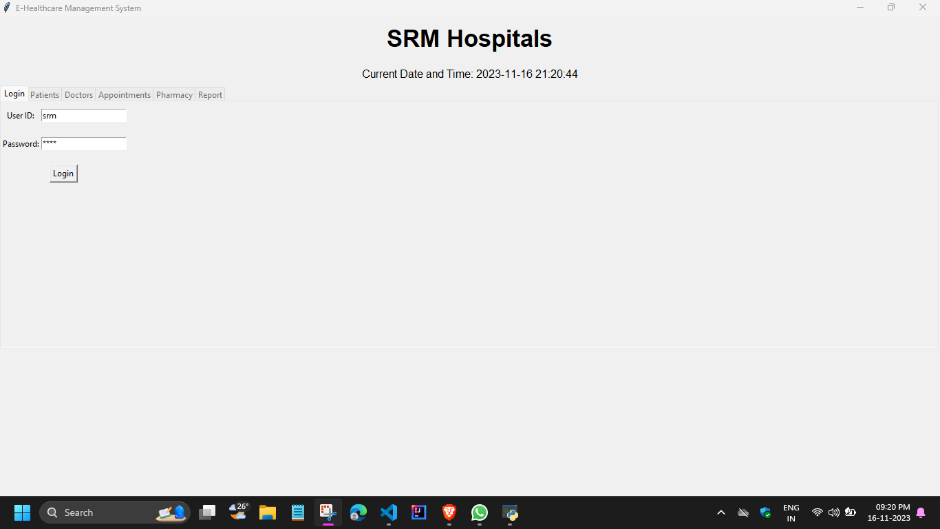
Other tabs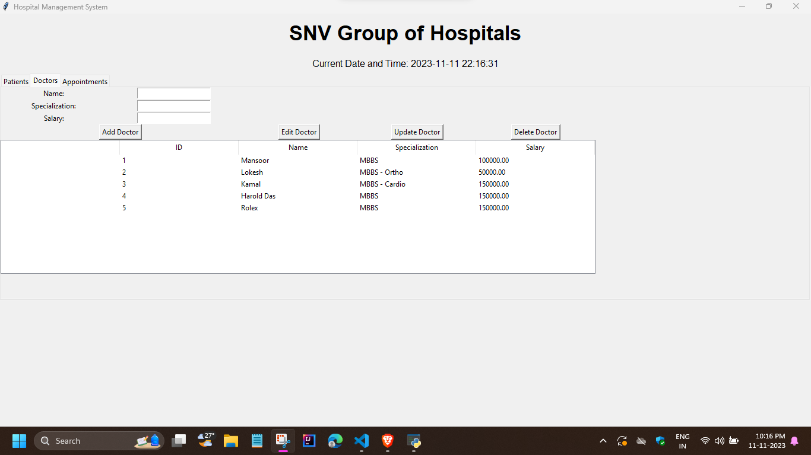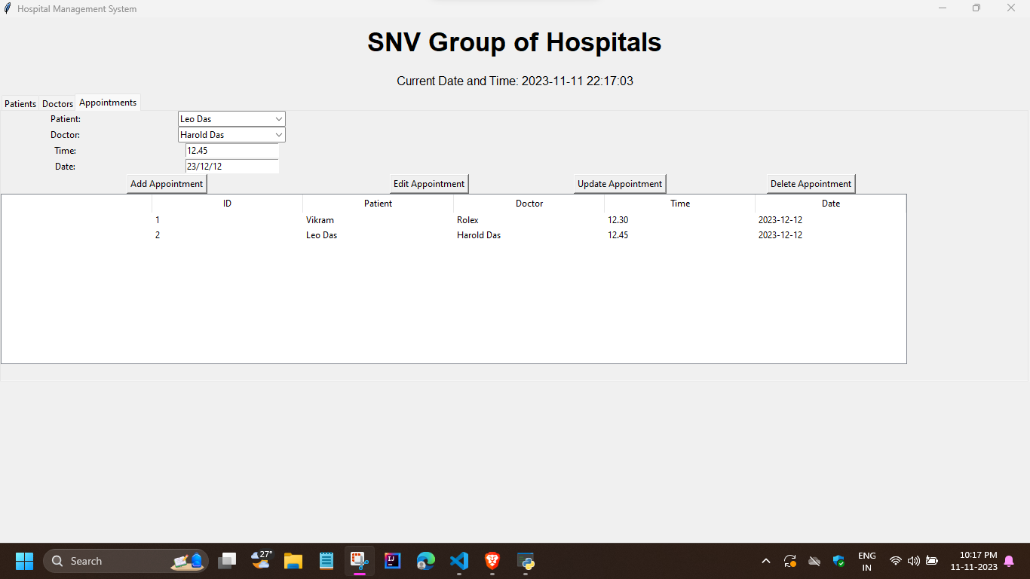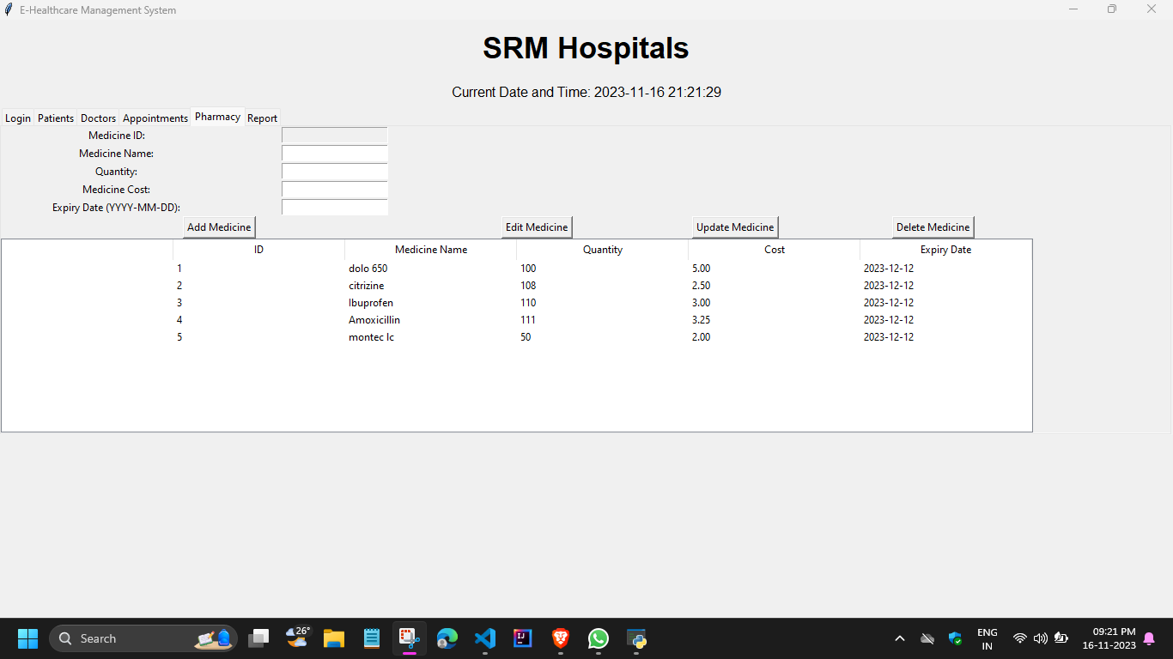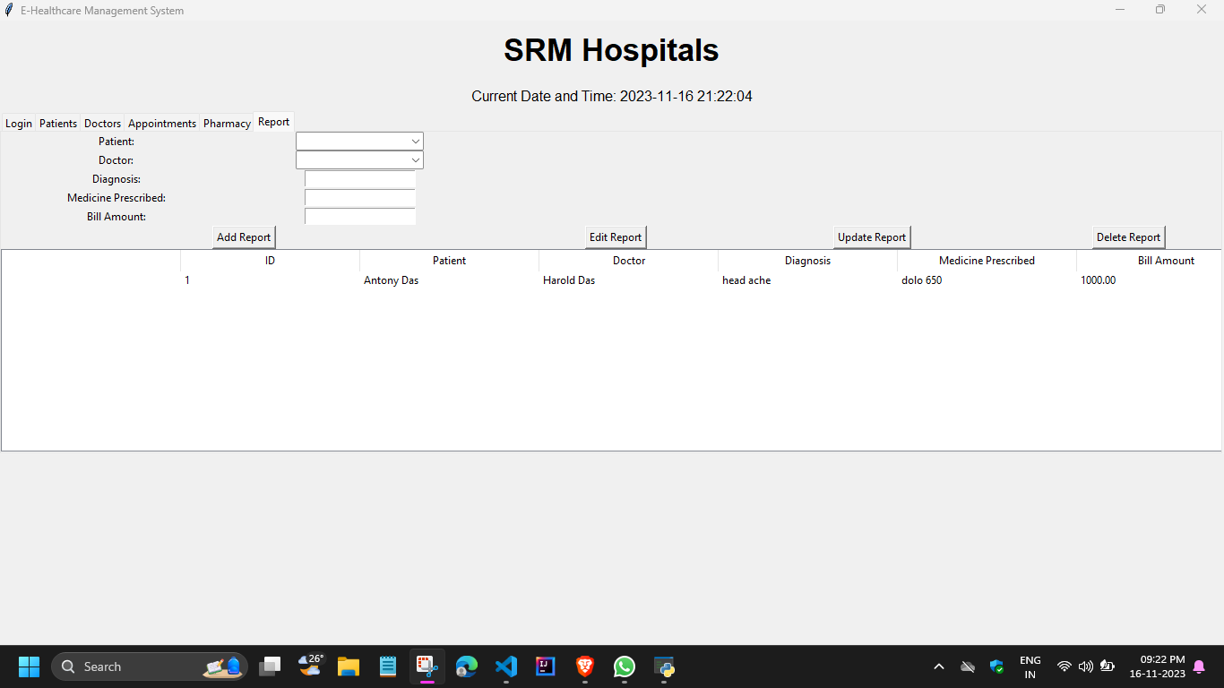
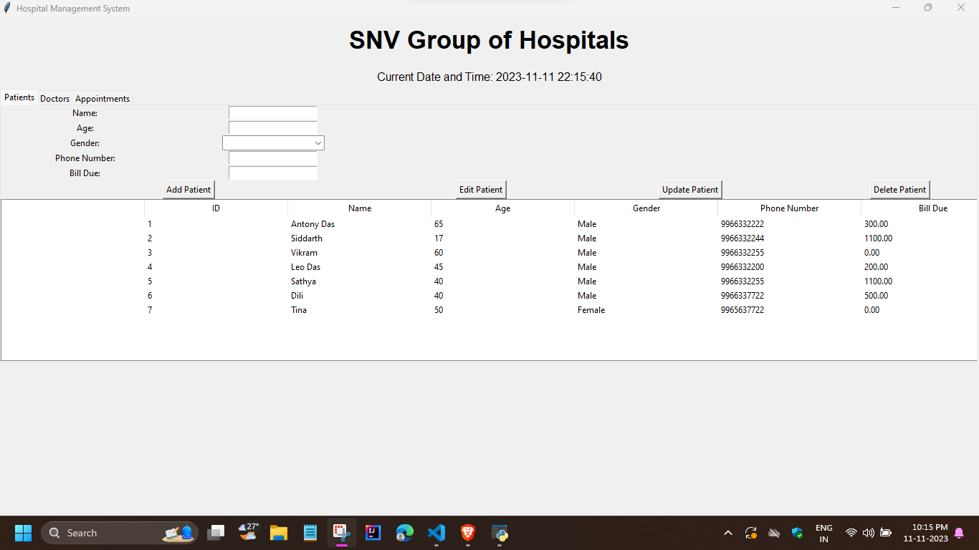

- CONCLUSION

In conclusion, the development of a Hospital Management System (HMS) using Python represents a significant stride towards enhancing the efficiency, accuracy, and overall quality of healthcare administration. Through a comprehensive literature survey, it is evident that the current state of hospital management often involves manual processes, leading to inefficiencies and potential errors. The integration of a well-designed HMS offers a solution to address these challenges and pave the way for a more streamlined healthcare ecosystem.

The primary objective of this project is to create a robust and user-friendly system that caters to the diverse needs of hospital staff, administrators, and patients. By leveraging Python's versatility, we aim to automate critical tasks such as patient registration, appointment scheduling, billing, and inventory management. The motivation behind this endeavor is rooted in the need for a centralized platform that not only facilitates efficient data management but also contributes to informed decision-making within the hospital environment.

While the project poses certain challenges, such as the integration of existing systems, user adoption, and ensuring data security and privacy, the literature survey has provided valuable insights into existing solutions and best practices. By addressing these challenges head-on, the developed HMS can serve as a scalable and adaptable solution for healthcare facilities, accommodating the growing demands of patient care and resource management.
In essence, the Hospital Management System using Python is poised to revolutionize healthcare administration by ushering in a new era of digitization, reducing manual errors, and fostering a more organized and efficient healthcare environment. Through careful consideration of the literature and a commitment to addressing challenges, this project aspires to contribute significantly to the advancement of healthcare systems, ultimately improving the delivery of patient care and optimizing the operational workflows within hospitals.

- REFERENCES

- Programming with Python – E Balagurusamy
- Class 12 – Computer Science with Python – Sumita Arora
- Class 12 – Computer Science (New) – 083 – NCERT
- APP – SRM PPT Material
- Python: A Beginner’s Guide – Herbert Schildt
- Advanced Python – Textbook
- https://openweathermap.org/api
- https://www.geeksforgeeks.org/introduction-to-tkinter/
- https://www.w3schools.com/sql/
- https://www3.ntu.edu.sg/home/ehchua/programming/python/tkinter
- https://www.youtube.com/watch?v=dPaUazOJOBc&list=PLGwb7xZHg-oNIUlzrLpurYaNfZBnU7hby

